Chapter 13, Solution 45.
48 Ω
Z
4∠–90˚

+
−

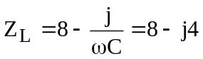, n = 1/3

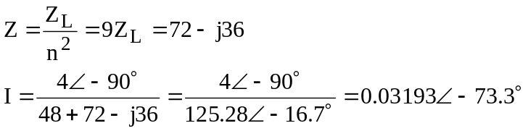

We now have some choices, we can go ahead and calculate the current in the second loop and calculate the power delivered to the 8-ohm resistor directly or we can merely say that the power delivered to the equivalent resistor in the primary side must be the same as the power delivered to the 8-ohm resistor. Therefore,

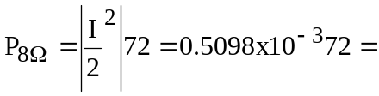36.71 mW

The student is encouraged to calculate the current in the secondary and calculate the power delivered to the 8-ohm resistor to verify that the above is correct.

